LAB-02
Name: MUHAMMAD TALHA
Reg No:UW-24-CS-BS-101
SEC : CS 2nd-B

:Lab Task # 02:

Student Table

Design View:

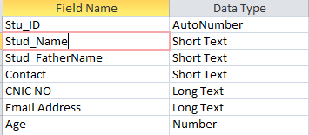

Rules Apply:
- Stud_Name:

- Stud_FatherName:

- Contact:

- CNIC No:

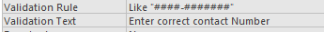
- Email Address:

- Age:

Errors
1st Error occur:
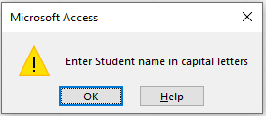

2nd Error occur:

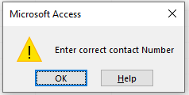
3rd Error occur:

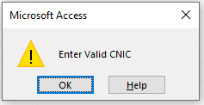

4th Error occur:

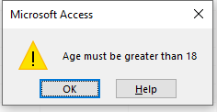
Full student Data Table

